**Chapter 1**

# Introduction

We live in a world where mobile development dominates, a world in which mobile phones are always with us to enhance our everyday lives, to give information, simplify tasks and provide entertainment. With the increase of mobile application called apps, individuals are seeking information on the go, this need allows developers to tailor make apps targeting exact needs of the users. Correlating this, Google play store and the iOS Store has more than 5 million apps (data from statista).

According to Statista 197 billion of mobile apps were downloaded in 2017, furthermore, 2.53 billion people use a smart phone, a report from Ofcom, confirms 55% of mobile owners uses their mobile phone to visit social networking sites or apps. Keeping this statistic in mind and with the increase of use of mobile application, it is not surprising to see an increase in the creation of app designed purposely for events.

Event apps offer information attendees needs, such as schedule, maps, date, time and more. Attendees download these apps so they can access information about any event they are interested in.

If we go back about 10 years ago, think how events where published, what comes to mind is a flyer. That old flyer, not designed properly, with no or less information printed on it and with all that typo(as once printed the organizer has no way of amending it). Yes exactly, those tedious flyers, that once received you will probably not even read and just bin.

Furthermore, if you are interested in that event, you will be handed that large paper with all critical information in it, address, date, event information and more, hoping it will not get lost in a mass of other papers.

Point is, mobile app illustrate the advancement society has made when it comes to tech, and for now this research is based on the development of user friendly Android based application named Univent. This event app will aid users in finding any upcoming events on campus and help event organizers to have a unique platform to publish their events and activities. This thesis will describe the design, development and evaluation of an app that will be used as a platform to publish any upcoming event in the University,

1

helping people to interactively engage in activities and events going on in campus.

## 1.1 Background & Context

Based on observation, students find it quite difficult to advertise upcoming events in University, with the only way being distribution of flyers around and most of these ending up in bins. It is quite difficult as well if the target is to reach as many students as possible within a short space of time. Flyers normally lack long term impact as many students may read the leaflet and then discard them. Most students that receive flyers will look at it once and if not interested will bin the leaflet as it’s not worth keeping. Therefore, they might not have anything to remind them of the event or service being advertised.

Furthermore, we live in a generation which likes to get information about activities on campus very easily, without carrying around flyers of any sort.

Moreover, the use of flyers affects the target, in that, to reach as many people as possible, for instance there might be University students who are interested in a particular event, but since they were not there at that moment of distributing the flyer they will not have the opportunity to know about the event. This will mean the individual will be unable to participate and they will not gain the benefit that event offered, this miss out on the opportunity of meeting new people for example.

## 1.2 Problem Definition

Whilst the 21st century digital world offers modern techniques, that can reduce cost, unfortunately flyers and leaflet distribution is still popular in Bournemouth University(BU). This form of advertisement, also known as leafleting, though may have quite an advantage because it’s easy to read, as the design of a leaflet tend to have larger letters and a limited number of words, as a fact they are designed predominantly to attract attention, not to go into too much detail.

**Limited Target:** the number of people reached is limited as this depends on the number of flyers that can physically be delivered.

Flyers have a trend to become obsolete, as people often order large quantities because higher quantity equals lower cost and there is a tendency of printing more material than needed for this reason. As events or services being promoted on the leaflets don’t last forever, it is quite important to distribute all brochure before the end date because discarding the remaining leaflet is a waste of money and paper.

Another main issue is the mistakes that can easily be made in print work, and when flyers are already printed out, this will turn into an extra cost to amend.

In our current era of tech, flyers is not the best way of publishing an event. It includes a long process to create a simple leaflet, finding words which are more compelling to your message, have a design, print and distribute the flyers. This process takes a long time and a lot of money if the leaflet needs to look professional, which consequently means working with a design company, photographer or a graphic artist. This often ends up being an arduous and expensive process.

Another disadvantage is that they are most often dismissed by people as “mere sheet of paper” according to an article at brochuremonsters.com. Complacency viewed by individuals as annoying, for those who don’t want to chat and don’t have time to stop and listen, to what is being advertised as they will rather do it in their own time. One might also glance at it for a second, but if it doesn’t spark any immediate interest it will end up in the nearest bin.

“This is very alarming as often it will end up as waste, and the main reason is that people are receiving leaflet they don’t want to receive”, said Ryan O’Quin, membership & development with the Ecology Action Centre in Halifax. Reducing the use of this form of advertisement will help the environment through the reduction of paper waste.

## 1.3 Solution

### 1.3.1 Existing solution

Although there are numerous event applications with the purpose of managing social events and activities, there is always room for more innovative ideas.

This thesis will analyse several existing applications in section 5.2.

### 1.3.2 Proposed solution

This project aims to create a paperless solution where information is always available and easy to access. With this solution students will rely on mobile application, allowing them to read or post any ongoing or upcoming events (club nights, parties, football matches, university events, external speakers, etc.).

Let’s consider the amount of time it takes to prepare flyers, create a design, decide on content, print and distribute, all of this is time consuming, and if you want the leaflet to look professional, this means hiring a marketing or design firm.

Flyers can be labour intensive and costly to produce and distribute especially if targeting a large audience and it’s very difficult sometimes to build a connection with a target who are always on the go. The number of people reached by flyers are very limited as this is highly dependant on the number of flyers you can distribute to the audience. It is also quite an arduous process, from design, printing and finding the perfect location to reach as many people as possible.

Another disadvantage is the finality of print compared to an app, once a poster is printed it is more difficult to make corrections or adaptions and it is therefore less flexible in its adaptability when compared to a software presentation that can be modified any time.

This is where a paperless solution for flyers has a powerful advantage. This minimizes your expenses, as there is no need to pay for printing and there is no need to worry about losing information, which can be accessed everywhere.

The application aims to provide the latest event on users mobile phone with all features designed to work online to give the latest information to users, and improve the event experience in every aspect: it is designed to build stronger connection for attendee satisfaction, a comprehensive event search to look for any interested event, have a customized event dashboard displaying only events of interest and more.

This application not only provides easy to access information to attendees, it helps organizers plan events, create the event, publish it and keep track of the number of attendees.

By providing all the benefit, and useful features of the application, it should show how essential it is to have a unique mobile platform for universities where events can be posted, minimizing effort and maximizing benefit to all attendees and event planners.

## 1.4 The Challenge

With the number of prospective students who use smartphone steadily increasing, along with internet usage, Universities are improving student experience and enabling them to see exactly what’s happening at the university and feel part of a wider community through use of tech. BU has already embraced social media and new technologies to engage its students through channels like, Facebook, twitter, BU app, etc.

The embracement of tech is further illustrated with BU own app, which enables students to find numerous information from checking their timetable to downloading lectures and seminars.

Infact it will be brilliant for this app the author has developed to be taken on board by the university and incorporated in the BU mobile app, as often integrating other apps on an internal system will be a challenge but as Doug Poole, digital media officer at Southampton University stated, -“it is worth persevering and joining these systems up as that is when the user will experience genuinely useful functionality”.

## 1.5 Target Audience

The main users of this mobile application will be everyone on the faculty. This is mainly designed to aid students and everyone at university to be aware of any ongoing activities or events at the university and help event organizers to have an easy platform to publish any activity they have organized. The app has a register and login feature which only accepts university emails, validates the user login details and checks a university email domain. This is one of the main feature of the app as it focuses solely on the University events and any other activities posted by students, this makes the app unique as all the similar mobile applications are targeted at a broader range of audience.

## 1.6 Project Aims

The application aims are to solve the problem mentioned above. To achieve this, the project must inspire and convince users away from printing out flyers or brochures and make it easier for students to post any upcoming events and reach as many audience as possible through the use of the app. Lecturers can post important events (external speaker etc.) and the University can post any important upcoming events. This project will make it much easier for people to connect and make each other aware of any events ongoing or upcoming events, through easy accessibility on their mobile phones. All these features are designed to work online to give the latest information to users and improve the event experience in every aspect.

## 1.7 Project Objective

The thesis objective should formulate a means to providing a solution to the problem, this following objective have been set out to fulfil this aim:

* To elicit requirements from observation
* Provide a solution that helps users to keep track of activities in the faculty and aid them in publishing any new ones.
* Design front end system that will show JSON data retrieved from server.
* App must work without delays and have smooth transaction
* Final project must work without issues, ensuring user safety

## 1.8 Risk

Risk in software project incorporates various factors or conditions that may represent an issue for the completion of the project. Risk can be divided into two component; the likelihood the risk will occur and the impact of the risk.

Managing risk includes identifying any potential risk, verify the impact on the functionality and come up with a strategy to control it.

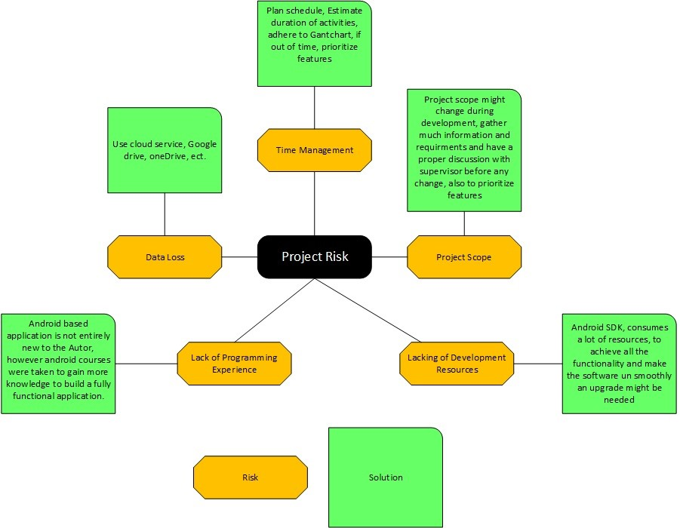

Figure 1.1: Risk Diagram

|  |  |
| --- | --- |
| Likelihood | Impact |
| P = Possible | M = Major |
| U = Unlikely | Me = Medium |
| L = Likely | Mi = Minor |
| V = Very Likely | N = No Impact |

Table 1.1: Likelihood and Impact

|  |  |  |  |  |  |  |  |  |  |
| --- | --- | --- | --- | --- | --- | --- | --- | --- | --- |
| Risk ID | | Risk | | Impact | | Likelihood | | Solution | |
| 1 | | Project Scope | | Me | | L | | Project scope might change during development, gather much information and requirments and have a proper discussion with supervisor before any change, also  to prioritize features | |
| 2 | | Time  Management | | Mi | | V | | Plan schedule, Estimate duration of activities, adhere to Gantchart, if out of time, prioritize features | |
| 3 | | Lacking of  Development  Resources | | M | | P | | Android SDK, consumes a lot of resources, to achieve all the functionality and make the software un smoothly an upgrade might be needed | |
| 4 | | Lack of  Programming  Experience | | Me | | L | | Android based application is not entirely new to the author, however android courses were taken to gain more knowledge to build a fully functional application. | |
| 5 | | Data Loss | | M | | V | | Use cloud service, Google drive, oneDrive, ect. | |

Table 1.2: Risk Analysis

## 1.9 Achievement

A mobile android application has been developed successfully and ready to go on the market. All requirements are met, and it has been tested by both client and developer and all necessary tests have been executed. The project accomplishes the following objectives:

* All functionality is integrated and working efficiently
* Multiple actions can be performed on the app
* Published on the Google Play Store Market and can be downloaded

## 1.10 Android vs iOS

This section explains the main operating systems on the market, those being Android and iOS, see Appendix B

## 1.11 Success Criteria

The measure of success is whether the project as a whole is a solution to the aforementioned problem. The app’s functionality will be evaluated throughout the entire software development lifecycle, in the form of debugging and running the application on a mobile device. Meeting with potential client will provide feedback that will aid in verifying most of the functionalities, this feedback may well lead to changes in functionality and appearance of each component. The main feature of the app is to provide support in publishing and keeping track of activities in the faculty, therefore the app will be uploaded on the play store, to enable users to download and leave comments regarding their experience of using the app which will allow collation of what feedback that can be utilised to gauge the overall success of the app and allow the developer to improve any areas of concerns relating to the main function of the app.

**Chapter 2**

# Methodology

## 2.1 Overview

User requirement changes continuously, and relying on a methodology help organize the development into phases, providing a more flexible development. This chapter will outline the approach that will be used in the project, with the aim that each one will aid in achieving the objectives.

## 2.2 Agile

“Agile methodologies are purported to imbue flexibility in software development projects, thereby enabling software development teams to perform more effectively”, Maruping et al. (2009). They share the property of iterative incremental development that tackles requirement changes quickly, satisfy customer and produce quality products, Hamed and Abushama (2013). Many Agile methodologies has been introduced, of these, XP and scrum are the most popular.

### 2.2.1 XP

Extreme Programming is a software development methodology designed to improve the quality of software and its ability to properly adapt to the changing needs of the consumer, Powell-Morse (2017). Similar to other Agile Methods of development, XP aims to provide iterative and frequent small releases throughout the project, allowing both team members and customers to examine and review the project’s progress throughout the entire System Development Life Cycle(SDLC).

Extreme Programming amends a software project in five essential ways; communication, simplicity, feedback, respect, and courage. Extreme Programmers get feedback by testing their software from day one and distribute the system to the customers as early as possible, implementing changes as suggested by the customer.

10

CHAPTER 2. METHODOLOGY

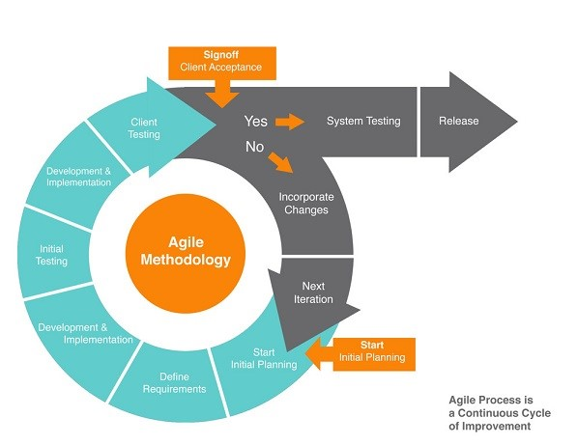

Figure 2.1: Agile Lifecycle

### 2.2.2 Scrum

Scrum is a subset of Agile and one of the most popular process frameworks for implementing Agile. It is an iterative software development model used to manage complex software and product development. Fixed-length iterations, called sprints lasting one to two weeks long, allow the team to ship software on a regular cadence. At the end of each sprint, stakeholders and team members meet to plan next steps, smartsheet (2016).

Scrum follows a set of rules; a scrum master has to be appointed, he/she normally conducts scrum meetings and makes decision. Scrum also relies heavily on backlog(list of features, bug fixes and improvement). These meetings aims to get developers to be more productive with an appropriate amount of supervision to handle issues that may arise.

## 2.3 Cowboy

Most methodologies focusses on groups of people to collaborate efficaciously to indite a software project, what about solo programmers? Cowboy was designed to fill this void.

Cowboy is an agile system that benefits from agile methodologies, customer centered approach and helps the programmer to stay focused while meeting customer needs. It is an iterative approach, meaning it adds features and fixes bugs of previous cycle.

Finally, cowboy suggest that the artefact should be kept simple and adequate, encapsulate the core ideas, which are subject to change(or even elimination) as requirement change, so not much time should be lost perfecting them, Hollar (2006).

According to Hollar, developers who had relied on this methodology includes; Alan

12 CHAPTER 2. METHODOLOGY

Turing, viewed as the precursor to the modern programmer, Bill Gates, essentially when inditing MS Basic.

## 2.4 How Agile Helped Cowboy

Cowboy relies on having a customer(or at least someone knowledgeable to represent the client interest). In this thesis it will be the supervisor of the project and a potential client interested in the development of the artefact. Their feedback should weigh somehow in deciding the order in which to add the features. The developer has autonomy over the development process and the authority to refuse a feature suggested by the client, which if pursued may take away vital time.

During development, cowboy suggests developers should target the huge problem first then move on to minor issues, code refactoring should be done during each cycle.

The combination with the agile methodology mentioned above, helped in the successful development of the application.

Deniz, agreed to act as the supervisor of this project and it was planned to hold weekly meetings, and continuous communication through email was relied on as well.

## 2.5 Project Plan

In order to have a successful project, a Gantchart has been developed. The chart breaks down the project into sub projects and provides the start and the end date of that particular sub project, refer to appendix **??**.

Bournemouth University, Department of Computing and Informatics, Final Year Project

**Chapter 3**

# Requirements & Analysis

## 3.1 Overview

Requirements are essential to software development, they define the property and the functionality of the software. This chapter looks at the requirement elicitation and method used for prioritisation of the requirements. It also mentions what are the main issue faced during an android app development.

## 3.2 Requirement & Analysis

Since this thesis has no client (stakeholder) to gather requirements from, the main objective of this projects was to solve a problem the author recognized, in the Bournemouth University, refer to section 1.2. Requirement was mainly defined based on observation and thorough research. Similar applications on the market (refer to section 5.2) were studied and from the result requirement were derived. In addition requirements gathered was discussed into detail with the project supervisor.

The beginning of the project was mainly spent observing how events and activities are organized on campus, trying to gain more knowledge on the method used and the effects in using such method. Thereafter further research was done on similar applications on the market, that can potentially aid in solving the issue. All of this lead to deriving the requirement needed to build the application.

After gathering the requirements the Numerical Assignment(Grouping) method was used to prioritize the requirements. Numerical assignment is the most common prioritization technique, this approach is based on grouping the requirements into priority groups, the number of groups can be different but normally its three (critical, standard, optional).

Listed below are the essential functional requirements of the mobile application.

13

14 CHAPTER 3. REQUIREMENTS & ANALYSIS

|  |  |
| --- | --- |
| Group | Requirements |
| Critical | The application should have a register and login screen |
| Critical | The application should integrate a validation for email, only universities email are accepted |
| Critical | The application should provide specific information such as event location, event start and end date, description, title. |
| Standard | The application should provide information of all attendees interested in an activity or event |
| standard | The application should have a “Share” feature. This will open any interested app installed on the users phone so they can share the event with friends |
| Standard | The application should provide a “Send Email” feature. This will open any email client installed on users phone, so they can email the event host for further information regarding the event |
| Standard | The application should have a “Map Feature”. This will direct the user to the Maps application with the event location already pre entered. |
| Standard | The application should have an “Add to Calendar” feature. This will open any calender application on the users phone and it will allow one to save the even on the calender creating a future reminder. |
| Standard | The application should allow the user to choose category they are most interested in and based on that information display all types of event or activities in those categories |
| Optional | The application should save the user login detail, so user has to login just once. |
| Standard | The application should show the location on a map directly on the screen of the app |

Table 3.1: List of Requirements

Bournemouth University, Department of Computing and Informatics, Final Year Project CHAPTER 3. REQUIREMENTS & ANALYSIS 15

## 3.3 Application Vision

The vision gives an idea of the functionality of the application. The purpose for this application is, that an individual who sees an activity or event, can get all the relevant information available on that event. Any other user with Android devices can participate, and also see who is already participating in that particular event. In order to do so, the user has to press on the button RSVP on the app, to be added to the attendee list and this information will be available to anyone who has access to the app but to maintain privacy only the nickname(username) of the attendee is shown. The target people for this app are users with Android devices who are currently enrolled in the university of Bournemouth.

The mobile app enables the user accomplish two main things: view existing event or activities that other users have created and create a new Event. To be able to add an event, the user must enter various information such as, event name, start date, start time, end date, end time, location, description, event type and an image(optional). On an extra view users can see only events based on their interest. The app offers the option to choose which category of event the user is interested in, which creates a second view with a personalized view of event recommendation based on the information provided. To be able to add an interest, the user has to go to the profile page and click on interest and then choose as many categories as they want. All information are stored to a database. If the internet connection is not enabled, the application will notify user that a connection is needed to continue, (unfortunately this feature was not included due to lack of time, it will be considered in future works). To upload the information to a database, the client must synchronize with the server, then the server will query the database. A user who wants to search through all events, can go to the menu, click on search, which allows them to search by event name. The application connects automatically with the database, and displays all events in order of date. The application provides the option to save any upcoming events the user is going to attend and also to show any event created by the user. The app has extra features to enhance the experience of the user, such as; they can share events with friends by clicking on the share button, they can also add the event to the calender by clicking on add to calendar feature, finally the app can direct the user to the maps app, providing the location of the event. To show the direction on the map, the users device has to have a location based application or have a browser installed. User also has the opportunity to email the event host directly by clicking on the send email button on the event information.

Bournemouth University, Department of Computing and Informatics, Final Year Project

**Chapter 4**

# Background Study

## 4.1 Overview

This section will show other areas which required further research to aid in making a concrete decision as to which technology will be used for the development of the project.

### 4.1.1 OS

The majority of the apps on our mobile phones are native apps, meaning they are written in languages that the platform accepts, for example swift is used to write iOS apps and java is used to write Android apps while c# is used for most Microsoft phone apps. Native apps are very responsive and also offer the most reliable experience to user. On the other hand an hybrid app is more similar to a web app but is installed like a native app. They are normally built with javascript, HTML, and CSS and runs in something called webview, a browser within the app. Performance wise, however, it’s inferior compared to native apps.

The project was developed as a native app, using the Android OS, this was chosen based on the fact the author has knowledge of the platform and it is the OS with the largest share on the market, mobiloud (no date).

### 4.1.2 Database

MYSQL was chosen as the database for this project, mainly for its scalability and its compatibility with Java and PHP language. For this reason phpMyAdmin was used aswell as a development tool to handle database management.

16

CHAPTER 4. BACKGROUND STUDY 17

## 4.2 Development Environment

Relying on tools to develop an app is very useful as it helps accelerate the development. For Android there are various tools which this chapter will focus on describing. To be able to build the application a development environment, Java Development Kit(JDK) and Android SDK are required. To develop with the SDK, Google offers a bundle, the bundle comes with an IDE and the Android SDK.

### 4.2.1 JDK

Java Development Kit is the essence of any java application. As defined by the Technopedia Dictionary, “the JDK is a software development environment used for developing Java applications and applets. It includes the Java Runtime Environment (JRE), an interpreter/loader (java), a compiler (javac), an archiver (jar), a documentation generator (javadoc) and other tools needed in Java development”.

### 4.2.2 SDK

Android Software Development Kit provides a selection of tools and libraries required to build Android apps to ensure the process goes as smoothly as possible and the SDK is used to get it to run on an Android device and access unique features of the OS.

### 4.2.3 Android Emulator

The emulator allows to run the app without having to install the app on an actual Android device. It emulates most of the functionality of a real Android device, apart from for the GPS module.

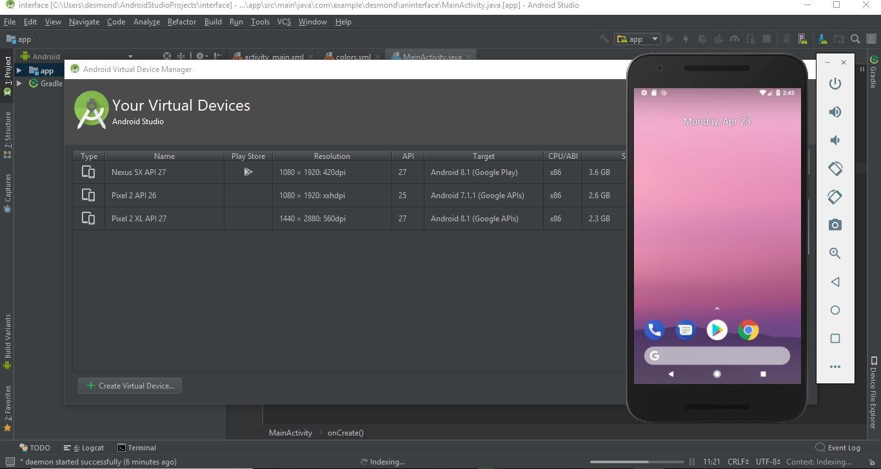

Figure 4.1: Android Emulator

### 4.2.4 Graphic Layout

The Layout Editor from the SDK allows developers to create user interfaces(UI) with an editor(Drag and Drop) or by writing XML Code. These editors support many features for

Bournemouth University, Department of Computing and Informatics, Final Year Project

CHAPTER 4. BACKGROUND STUDY

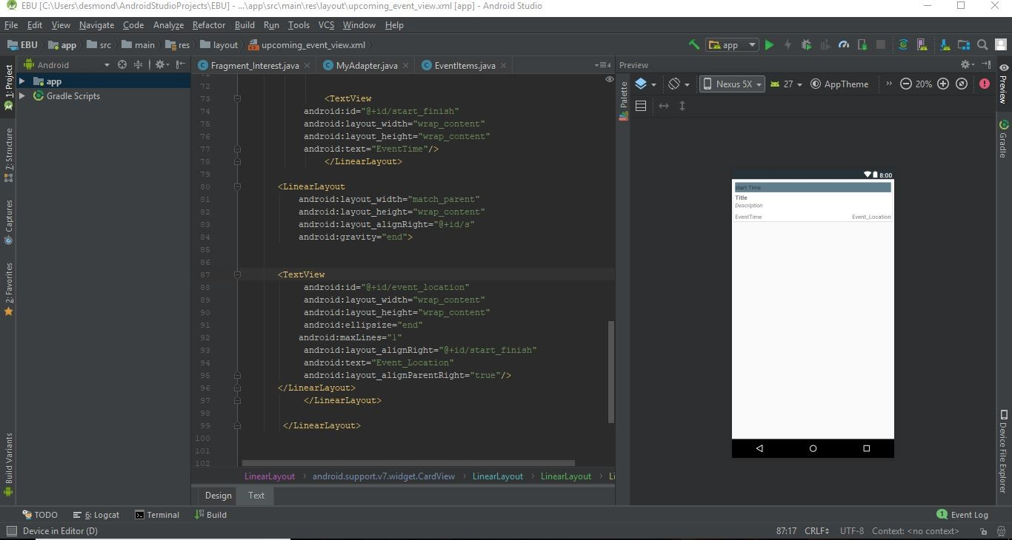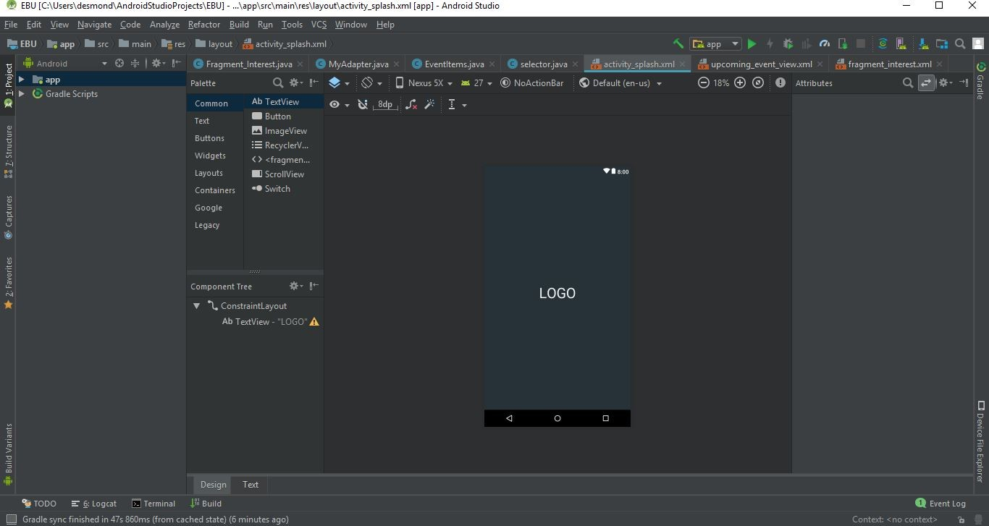

(a) XML Text View Editor (b) XML Design View Editor

Figure 4.2: Andriod UI Design Editor

rapid UI development and both are easy to use and it is directly included into Android Studio. The screen of the editor is shown in figure 4.2.

### 4.2.5 IDE

According to TechTarget Integrated Development Enviroment(IDE) is “a software suit that consolidates the basic tool developers needs to write and test software. An IDE consists of a code editor, a compiler or interpreter and a debugger that the developer can access through a single graphical user interface”. For the purpose of this project Android studio was used as its the official IDE for Android development.

## 4.3 Android Framework and API

In order to build the artefact, it is essential for the author to understand the Android framework and API, this information is found in Appendix E.

## 4.4 Developing Problem

Dealing with diverse platform is on of the most challenging aspect in app development. Mobile development is moving towards fragmentation rather than unification.

**Fragmentation:** Considering Android devices, most of them comes with different screen resolution. Different devices exist with different properties such as CPU speed and memory. According to a study made by Mona, Ali and Phillipe in their article “Real Challenges in Mobile app Development”; 76% of their survey participants see the existence of multiple platform as a challenge for developing mobile apps, while 23% believe it is an opportunity for technology advances that drive innovation. The development process cannot leverage knowledge from a platform to another. Also, when an application is created for various platforms, the developers must treat the development independently and check that consistency is kept across each one.

**Chapter 5**

# Literature Review

The concept paperless has been around for some time now and has long been the dream for most organisations and individuals, however it’s yet to be realised. Paper is an essential part of our daily life. People learned how to organize their tasks, previous generations, more used it to pass their wisdom to current generation, many individuals cannot imagine their lives without paper. However with the rapid growth of Information Technology(IT), many things are changing. Nowadays most people want immediate or instant services, they want access to information at any time at any place. As such the pedestal that paper used to rest on appears to be becoming obsolete, therefore many organizations are trying to reduce the use of paper.

Isaeva and Yoon (2016) published an article on paperless Universities, they mention that no matter how IT is progressing the idea of paperless is still a dream for many companies and the case looks more critical when it comes to Universities - “the biggest paper consumer organization”. They posed a pressing question, “Is it possible to make a campus paperless, or will it forever remain as a dream?”. Nowadays universities around the world have adopted computer-based systems. However, the management systems of universities are still paper based. The article goes on to mention some reasons for going paperless as the following;

* Reduce the amount of paper used;
* Reduce the amount of time spent searching and retrieving documents;
* Reduce the amount of duplicate data;
* Decrease the physical space allocated to file storage;
* Increase flexibility of documents’ use and security;
* Increase efficiency of university administration processes; • help to save natural resources;

19

CHAPTER 5. LITERATURE REVIEW

According to an article published on the Yale University website, during the year 2011 the University consumed 211,033 reams of paper - “that’s enough paper, if laid end to end, will stretch three-quarters of the way around the earth”. Using paper doesn’t only take up natural resources, it’s also very expensive, (i.e, printing, storage, disposing, recycling and processing). Recognizing this, Yale Universities departments and schools initiated different steps to go green, not only are they benefiting the environment and financially by shifting to digital solutions. For example: The office of Student Employment saved $100,000 by replacing paper timesheets to electronic timetables. The School of Medicine economized $92,000 when the submission of course works in paper were replaced with electronic versions. The department of Finance and Business Operations managed to save around $60,000 when they started publishing their annual reports online, Ngim (2013).

The above showcases the reason in going paperless in going paperless: Cost saving, improving data sharing, avoiding duplicate. Many organisations are trying to implement paperless, however, it is not an easy task. Although many people are comfortable with technology there are still reservations when new developments are made, this is unsurprising as most fear the unknown. A paperless world is a huge leap into the unknown. However this may be managed in two ways: Graphic User Interface(GUI) and Gamification.

As mentioned in Isaeva and Yoon (2016) article, a very important factor is simplified GUI. Sometimes developers implements many functions to the system and end up having a cramped system with lot of useless information. As an outcome users feel lost. Developers should focus on making easy and more user-friendly GUI.

**Gamification -** is a comparatively new term that is used to describe the use of game elements and game design technique in non game context. The aim of this method is to induce a certain behaviour in people by relying on game mechanics to improve motivation and involvement in a specific task. According to the self Determination Theory written by Deci and Ryan (2008), people have extrinsic and intrinsic motivation to perform a task. Extrinsic is about the rewards and prizes, on the other hand intrinsic is related to the task performed because its fun and people like it. Websites like stakoverflow uses gamification to try and keep user motivated to perform a certain task. This system is normally driven by points, for example on stackoverflow, an online programming community, rewards users with points and badges after they have posted a number of questions or replied to questions posted by other users. The most popular elements are leaderboard and bagdes,

Nowadays, the newer generations make exhaustive use of digital technologies. They like to learn relying on technology, its not surprising that, the use of game elements in a non-game context seems a choice to be used in education, it has been used as an inspiration of engagement, motivation to boost learning by providing an environment that

CHAPTER 5. LITERATURE REVIEW

supports cooperation, competition, feedback and reward, Kaplan and Haenlein (2010).

Hamari et al. (2014) made a research about “Does Gamification Work?”, based on his assumption, gamification is seen in three main component. First is the motivation effect, second is the psychological outcomes and third is behavioral outcomes. Ways to entice users to keep using a gamification product is to make them feel that the activities are worthy. Applying gamification have to go through a clear arrangement to have an impact on users. The game elements has to be selected cautiously because every game element has it’s own function. A bad gamification design can have an harmful effect on the system, Hanus and Fox (2015).

According to a survey made by Uskov and Sekar (2014), in which they interviewed 18 volunteer students to collect their feedback about the impact of badges and leaderboards during a course experience and they also interviewed six students which were randomly selected for interviews about their perceptions about the course and the use of game elements. Their results shows that, the concept of badges had a greater impact on the motivation of students than the leaderboards. Students had shown more interest in gaining badges and saw them a social reward and secondary objectives to strive for in the course.

## 5.1 Applying Gamification to Univent

Gamification can be used as a means of promoting rewards for completing tasks. In the learning environment, students can be rewarded for taking the initiative to improve their soft skills. In this way, some of the discrepancies in personal efforts that are often present in student project work are reduced. The same technique can be applied to Univent, allowing individuals to publish an event and rewards up front often goes a long way to ensuring that all individuals are working towards paperless. Moreover, integrating a gamification system according to which, when a user achieves a goal it triggers a reward system based on gaining points. In this way, the user’s interactions with the app will be more focused on going paperless. The reward system based on points is aimed to measure the paperless success of a host, the number will increase, and decrease based on the reaction of their events, so the points will change depending on the upvote or downvote that were made on the host’s feed. The same effect on the points was determined by how many paperless events a user decides to host (host will be able to tick a box to declare they are going 100% paperless for that event, meaning the will only use Univent to advertise plus they will not use paper base advert such as posters). The more point and upvotes a host gets can get them more ad space, meaning that each event they post will be of high priority and will be added at the top of the event list and will further be added to the recommendation section on the app, potentially increasing the number of views.

CHAPTER 5. LITERATURE REVIEW

## 5.2 Related Work

This section will explore the functionality and the utility of existing solution that will be viewed as competitors.

### 5.2.1 Fever

Fever is an event discovery and booking app for iOS and Android. It provides information on the best events in major holiday destinations in Spain with expansion to major international cities like London, New York. Fever inspires users to find out about what these cities has to offer, from music festivals to fashion and restaurants.

The app also looks at each user’s top three interests, their activity, and interactions with other Fever users to offer a better recommendation engine.

Fever is more a location based app, meaning the app uses the users location in order to find which events to promote. Although it’s not targeted at the locals as they may already be aware of most of the services suggested, conversely it is likely to be of tremendous interest to people who are new to the city and will like to discover the best restaurants. Furthermore Fever only publishes event that they have personally selected and is not open to public posting. However, if someone outside of Fever wants to promote on their app they can fill out a form, but this is a long process to advertise on the app. The app is only currently available in: New York, London, Paris, Madrid, Barcelona, Seville, Valencia, Bilbao and Malaga.

### 5.2.2 EventBrite

This application allows the user to find what’s trending nearby at a wide variety of venues. They can keep up to date with any upcoming event like concerts, festivals, holiday events and networking events. Eventbrite enables users to buy tickets directly on the app stored on the mobile phone for convenience access. Users can also store their credit and debit card details for faster payment. The application can find things to do based on what the user is into, where they want to go or when they want to go out. This will provide a recommendation of events for the user, based on all these information. The application includes a share feature where users can share events with friends and vice versa and the app is available in German, Spanish, French, Italian, Dutch, Portuguese, and Swedish.

Overall the Eventbrite app has similar features to what is described in the application vision, see section 3.3 and even more features and currently more than 5 million downloads according to the play store. One major drawback of this application, however, is that, the mobile app doesn’t have the feature that allows to add events. The only way to add an event is to use their main website and it’s more suited to larger enterprises who are looking for a more convenient, visual way to manage their events.

CHAPTER 5. LITERATURE REVIEW

Currently Eventbrite is based on events worldwide, giving the user access to events in various parts of the world. Univent will still be unique, as at the moment there is no app that covers events or activities just for Universities (in this case the Bournemouth University) or any event related to the members enrolled on the faculty.

## 5.3 Summary

Eventbrite and Fever are good examples of how Univent will work. They showcases the main features and how tasks can be handled. Furthermore, the review of both provides a better understanding of what features are required and gives the opportunity to identify any missing features that could be important to implement for an all round user experience.

**Chapter 6**

# Univent Design

## 6.1 Overview

The app design is a very important phase of the development lifecycle, as it can have an impact whether or not the app is accepted by the users. This chapter presents the choices made for the design of the aplication.

## 6.2 Android Application Design

The user interface is designed using widgets. Android provides basic widgets such as, image view, textview, etc., which can be used to create the application. All these widgets are incuded in the Android SDK. Android gives users the possibility to create their own widgets, named custom widgets.

All the screens in the project are composed of various widgets, both basic and customized.

The home screen, includes widgets such as, RecycleView, TextView, ImageView. The recycleview is populated with data directly from the database.

* **TextView** - A textview displays text to the user, normally displaying contextual information or the name of other elements on the screen. Figure 6.1, shows how to define a text view in the XML editor.

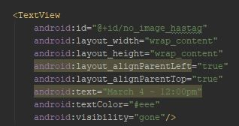

Figure 6.1: Define a TextView in XML

24

CHAPTER 6. UNIVENT DESIGN

* **ImageView** - An Imageview is used to display image to the user from the resource file or from an external source, like the internet. The following snippet is an example of imageview, refer to figure 6.2

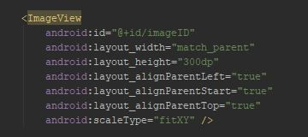

Figure 6.2: Define a ImageView in XML

* **RecycleView** - According to the official android website, “a Recycleview is a view group that displays a list of scrollable items”. The list items are automatically inserted to the list using an Adapter that pulls content from a source such as an array or database query and converts each item result into a view that’s placed into the list. Figure 6.3, shows how to declare a recycle view.

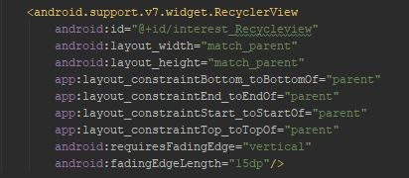

Figure 6.3: Defining RecycleView

Recycleviews are normally accompanied with cardveiws, these shows information inside cards, and its corners can be customized by the user. The main function of these cards is to act as the rows of the recycleview.

* **ViewPager -** A viewPager is viewgroup that allows the user to swipe left or right to display a new screen. Its a more efficient and user friendly way of displaying screens to users, refer to Appendix A.

CHAPTER 6. UNIVENT DESIGN

## 6.3 Initial Design

Before the final design of the app was created, various designs were made in attempt to give a better UI experience to the user, refer to Appendix A. All the designs were made with the Android XML editor to see exactly how it will look on a mobile device. Using the XML editor made designing simple, meaning no need of wireframe designs before recreating them for the app, which saved a lot of time. All the widgets mentioned above in section 6.2, were used to complete the design. Extensive research on similar applications, section 5.2, provided inspiration for the final look of the app and the meeting with the client also provided ideas for new features to implement. The app was further redesigned to be more user friendly, with two new screens created, Discover and Interest(named as ”for you” in the app), using viewpager, as detailed in 6.2, so users can swipe left or right to move between screens as shown below in figure 6.4.

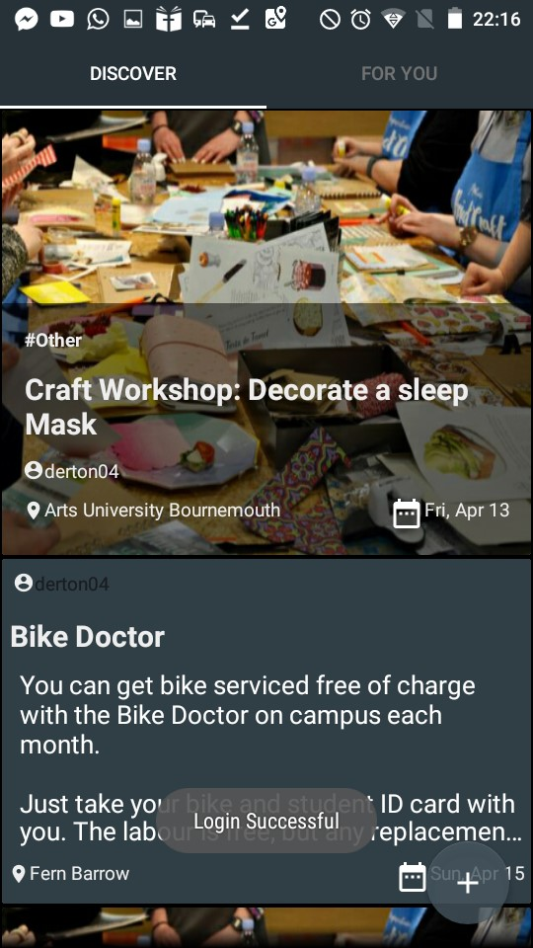

Figure 6.4: Home Screen

The discover screen shows all the upcoming events with no filter, while the ”for you” screen shows only recommended events based on the user interest. In order to achieve this a new feature was to be added, as a way for the user to choose what they were into.

A snippet of the Interest screen can be found in Appendix A.

CHAPTER 6. UNIVENT DESIGN

## 6.4 Database Design

Figure 6.5, describes the structure of the database. The event table contains all the information of the event, the user table has all the user information and finally the GoingTable, contains the ID of the users an the specific event ID the wish to attend.

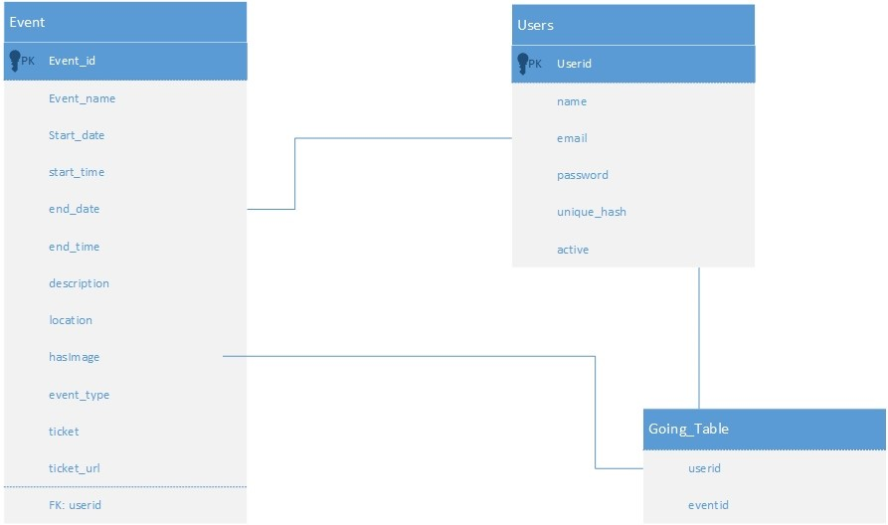

Figure 6.5: Database Design

### 6.4.1 Security

Considering the importance of data it is not a surprise for attackers to target the data these are containing. In this section various challenges in database security are discussed.

* **Blank Password, blank email:** In order to avoid this issue, a password and email validation has been put in place, which will notify the user if any of the fields are left blank.
* **Secure credential:** User passwords are not stored directly onto the database, but are encrypted using a hash key. The hash key is then stored in the database, whenever the password is called it is then decoded.
* **Excessive privileges:** Granting Users (or applications) database privileges that exceed the requirements of their task, these privileges may be abused for malicious actions.

CHAPTER 6. UNIVENT DESIGN

* **Weak Authentication:** Weak authentication allows attackers to take the identity of database users. A counter measure for this issue will be to Implement a two-factor authentication.

### 6.4.2 General Architecture

An Android device with the Univent application already installed communicates with the web service using a RESTful API. The application sends HTTP requests with GET/POST method headers and receives formatted JSON responses. The API is written in PHP and handles querying the MYSQL database. Figure 6.6, shows the system architecture.

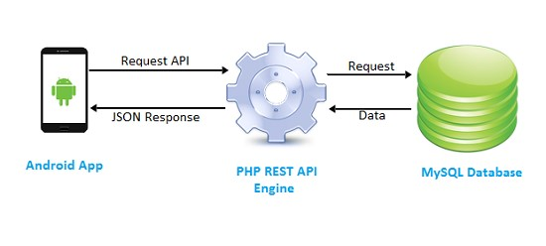

Figure 6.6: Rest API

**Chapter 7**

# Implementation

## 7.1 Overview

This section will describe how the features were implemented to develop the final artefact, the system will be developed using Android studio.

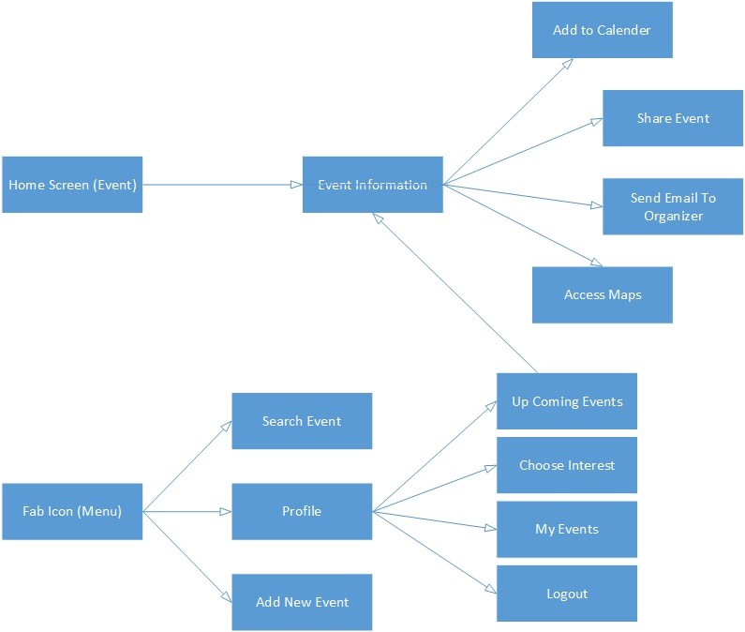

Figure 7.1: Logic Flow of Screen

The figure above 7.1 shows the relationship between each activity(screen), how to move between screens. Both screens, upcoming event and homescreen link back to event information, because this option is available from both activities, meaning the user can access event information from both. Add to calender, share event, send email to organizer and access maps are all behind event information, this means the logic behind each of those activities has to be implemented in the event information activity. Fab icon, refer to figure 7.2, is a navigation menu that links to search event, profile and add new event.

29

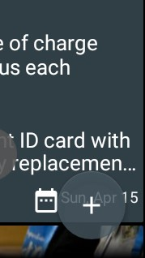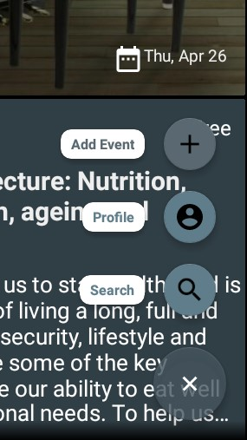

(a) Fab Not Clicked (b) Fab Clicked

Figure 7.2: Fab Menu

## 7.2 Login & Register

The login.xml has the function to display the views to the user while the login activity has the function to handle all the java logic in the background. This activity will ask the user to login, user then has to select their university, enter university email and password, this information is then checked against the user database; if the user has already got an account and the password is correct the user will be logged in successfully. This activity also checks if the user account is verified or not and displays the appropriate message. The user can move from the login activity to the Register activity by clicking on the textview, ”not registered”. Refer to appendix A, for details on screen design.

Activities relies on intent, refer to Appendix E.3, to move from one activity to the other, the figure below 7.3 shows an example of how to move from the login activity to the register activity. Intent also allows data passage between activities; for the purposes of this app data such as user email, user ID, was passed through activities to maintain traceability. In order to enhance the user experience, shared preferences APIs was used to store

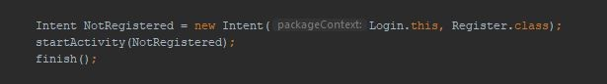

Figure 7.3: Declaring an Intent

user login details on their phone(internal memory of the phone). Shared preferences permits saving and retrieving key value pair data to be used to save primitive data type such as Boolean, string, int, long and float.

**MODE PRIVATE** – this is the most used mode of sharedPreferences, It is a default mode, which means that when any preference file is created it will only be accessible from the application.

Calling the edit() function of SharedPreferences class which returns Editor class object allows to save data into sharePreferences, refer to figure 7.4

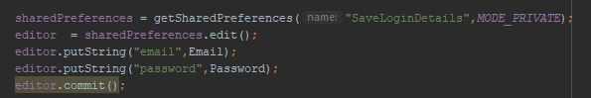

Figure 7.4: Declaring SharePreferences

Values stored in shared preferences can be called using SharedPreferences object by calling different primitive type function starting with get plus the Primitive type name, refer to figure 7.5

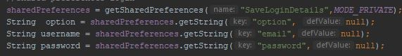

Figure 7.5: SharePreferences key value pair data

The **register activity** allows the user to create an account if they are not previously registered. It prompts the user to enter their details, university name, nickname, email and password. Afterwards, before registering the user, it verifies if the user does not have a previous account, if so it will displays a message. Otherwise it creates an account and sends a verification email to the users email address to verify their account, refer to appendix A.

Once the user is registered and logged in, the app receives all the event data from the server and displays it on the home screen.

## 7.3 Implementation of REST API

REST stands for ”Representational State Transfer” REST architecture will be used to build the client/server applications. It’s simple to implement REST as it basically works on HTTP protocol, refer to figure 7.6 below.

Since Android does not have a dedicated library for implementing A REST API, it provides a number of pre-implemented solutions that can be used for the implementation. According to Bedynski (2011), the main issue however, is how to design an action flow´ between components of the system from the presentation layer (Activities) down to the network and local memory operations. He also mentions that there is nothing like the best way of implementing a RESTful API client on Android platform because each solution can,

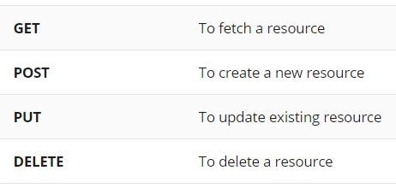

Figure 7.6: HTTP Methods

and should be modified according to the unique requirements of the protocol, however, there is one pattern which is definitely not advised, that is to, avoid running RESTful methods directly from the UI thread.

* this would cause and ANR (Application Not Responding error).
* slow down the application and make it less responsive

Android however provides a solution, AsyncTask, which is a high-level concurrent construct. AsyncTask can interact with the UI thread by updating the UI via event handlers. For example, the event handler ***onPostExecute*** executes after the task is finished, and can update the UI with the task results. A study by, Lin and Dig (2015), shows AsyncTask is the most used async construct in Android. However, it is designed for short-running tasks (i.e., less than one second) and if improperly used, can lead to memory leaks and lost results.

The basic methods used in an android AsyncTask class are defined in the table below:

|  |  |
| --- | --- |
| Method | Function |
| doInBackground() | This method contains the code which will be executed in the background |
| onPreExecute() | This method contains the code which will be executed before the ***doInBackground*** method |
| onProgressUpdate() | This method receives progress updates from ***doInBackground*** method |
| onPostExecute() | This method is executed after ***doInBackground*** completes processing and the result from ***doInBackground*** is passed to this method |

Table 7.1: AsynTask Methods

### 7.3.1 Sending Request to the Server

There are multiple networking libraries and classes available for Android that can send POST requests, however, the preferred method is through HttpUrlConnection. This section will describe how to send request from Android client to the server;

**Giving Permission to Android:** Univent requires an internet connection in order to get information about the event and to retrieve data from the database. All required permissions must be declared in the AndroidManifest.xml file.



Figure 7.7: Internet Permission

**Connecting to the Server using URL:** The URL object, refer to figure 7.8, contains all the necessary information to reach the destination resource. In this example, the url is pointing to the php file on the server, named get event.php. This file handles the query to get all events from the database. URLs are constructed as sets of information. Lets consider the URL:

#### http://derton04.000webhostapp.com/login.php?parameter=value

In the example above, http is the protocol, derton04.000webhostapp.com is the domain name, and login.php the path. Parameter a query parameter key (called key), value a query parameter value (named as value), and parameter=value a query parameter key-value pair (referred to as key-value pair).



Figure 7.8: URL to get all Events in the Database

In the next step, 7.9, the methods and properties of the request object are set. First, set the method as request method to be invoked as POST. The method setDoOutput, needs to be set to true before sending a post request. setDoOutput is not needed for GET requests.

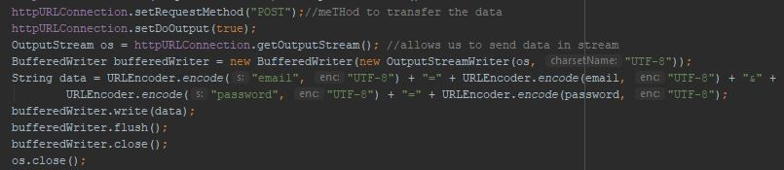

Figure 7.9: URL to get all Events in the Database

This library also gives the possibility of including data in the request. The URLConnection class provides an OutputStream object as the mechanism for providing this data, for performances reason it is wrapped in a buffered writer. The parameters/data are then attached to the url, then encoded onto the outPutStream before being transmitted over the internet.

The snippet below, figure 7.10 checks if the connection was successful and if the data has been transmitted.

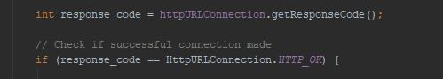

Figure 7.10: Check if Connection is OK

The figure below, 7.11shows the status code of an http connection.



Figure 7.11: Status Code

After receiving the Http status code OK, the URL will return some values that are directly coming from the database. Using inputStream and the String builder class, will fetch this data(JSON format) and store it in the variable, in this case result.

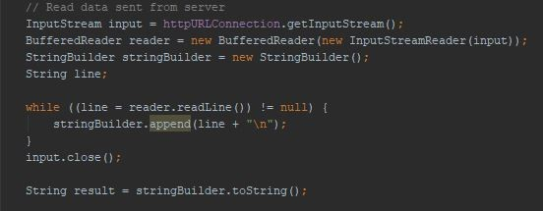

Figure 7.12: Status Code

Figure 7.13, shows how the data is parsed using JSON parsing technique inside android application and then set into recycleview. To access the database, it requires an

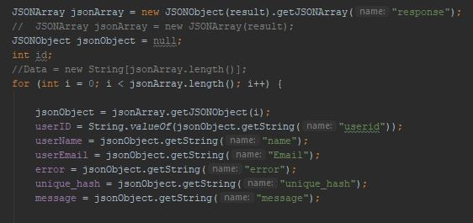

Figure 7.13: Parsing JSON

interface, first, it must receive JSON data, add data and update the database, secondly, it must deliver JSON data containing events in the database. A PHP scripts is used to provide this interface, below is a complete example of connecting an android application with MYSQL database via PHP script. It creates a basic application that retrieves data from MYSQL database using GET and POST method.

The PHP page given below takes parameters(userid) by POST method, and displays all event in the database created by that userid. The result will be displayed in JSON format. The PHP file is responsible for handling the communication with the database, to

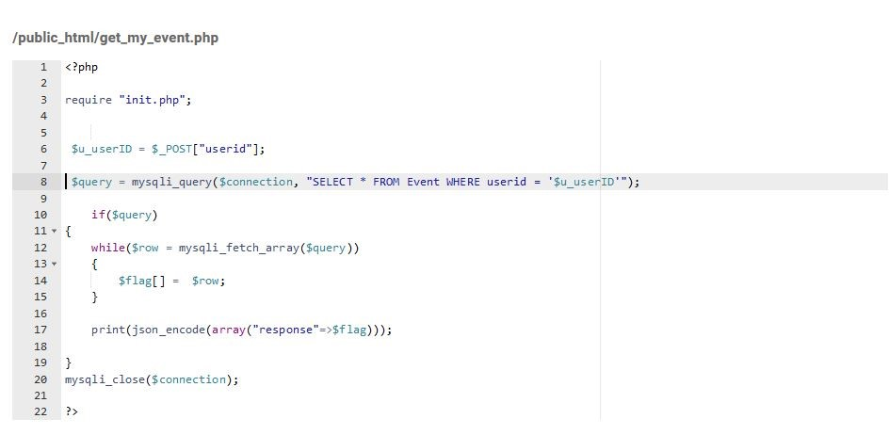

Figure 7.14: PHP Page

insert, update, retrieve and delete data. To do so, the query is embedded in the PHP file. The PHP file is then capable of establishing the connection with the MySQL database and execute the required query.

**JSON -** JSON (JavaScript Object Notation) is a lightweight text-data interchange format used to transmit data in form of objects(structured data: key value pairs) over the internet. JSON also supports string, Boolean, number, array and null formats for storing data. After the database operation is done, the server will save the result as JSON format, and send it to the requesting client, refer to Appendix C for an example of JSON data format.

## 7.4 Sending Image to Server

This section explains how the images of each event were uploaded to the server using the Volley library, see Appendix F.

## 7.5 Testing

To ensure the system was tested thoroughly a test suit was designed. Test results are shown is Appendix D.

### 7.5.1 System Testing

The purpose of system testing is to test Univent against the functional requirements declared in section 3. Appendix D detail the system testing.

### 7.5.2 Black Box Testing

Android app must be tested on the emulators, but it is important to test the app in the real world. The app has been constantly been tested from initial installation to daily use of app as per the end users point of view. This method is more powerful to come to know if any issues become visible in Android apps, as issues will surface in day to day use.

After each new functionality added, a thorough testing is done by the author, the supervisor and some experimental users. This method resulted in being very effective as some defects, with varying severity, were identified, for example, the send email button in the event information page, was meant to send an email to the event host, instead it was sending the email to the actual user. Another behaviour identified that was very crucial, was the login validation, user were allowed to register with a blank password, therefore they could login without typing in the password.

## 7.6 Publishing to Play Store

After all testing has been completed, the application was published on the Google Play Store. The app was released on the Android Market under the name Univent and it will be free for all users.

**Chapter 8**

# Evaluation

## 8.1 Overview

As usability is quite crucial for the success of the application, a random selection of users were offered to try the application. Once they had tested the app they were asked to leave a review on the play store and fill out a survey. Below is the outcome of the survey and some of the reviews.

|  |  |
| --- | --- |
| Question | Score |
| How would you rate the mobile app? | Weighted average is 4.75 out of 5 stars |
| I found the system really easy to use | 75% Strongly agree, 25% Agree |
| I would need assistance to be able to use the app. | 50% neither agree or disagree, 25% diasagree and the other 25% strongly disagree |
| How visually appealing is the app? | 50% Extremely appealing, 25% Very appealing and the other 25% Somewhat appealing |
| I think I would use the app frequently | 75% agree and 25% strongly agree |
| How likely is it that you would recommend the app to a friend or colleague? | 50% Extremely likely and 50% very likely |
| Do you have any other comments about how we can improve the app? | see table 8.2 |

Table 8.1: Survey

37

CHAPTER 8. EVALUATION

|  |  |
| --- | --- |
| User | Comments |
| User 1 | Good app, allows you to view events from Bournemouth University, allows you to add your own events, simple to use nice layout |
| User 2 | Very good app, simple user friendly interface |
| User3 | Create a version compatible with apple iPhones |
| User 4 | Some usability issues when you verify your email address, I had to re enter Bournemouth University before i could sign in, I didnt know I had to do that without guidance |
| User 5 | Pretty good app. Perfect for checking available BU uni events convenient use. Layout is nice and simple. Good simple app |

Table 8.2: User Comments

For general feedback, refer to table 8.1 and 8.2. The screen design received very good feedback; the participants noticed how the screens were appealing and they also noticed how useful the artefact could be.

### 8.1.1 Requirements Evaluation

In terms of functionality all the requirements mentioned in chapter 3 have been met.

|  |  |
| --- | --- |
| Requirements | Met?Yes/No |
| The application should have a register and login screen | Yes |
| The application should integrate a validation for email, only  Universities email are accepted | Yes |
| The application should provide specific information such as event location, event start and end date, description, title. | Yes |
| The application should provide information of all attendees interested in an activity or event | Yes |

CHAPTER 8. EVALUATION

|  |  |
| --- | --- |
| The application should have a “Share” feature. This will open any related app installed on the users phone so they can share the event with friends | Yes |
| The application should provide a “Send Email” feature. This will open any email client installed on users phone, so they can email the event host for further information regarding the event | Yes |
| The application should have a “Map Feature”. This will direct the user to the Maps application with the event location already pre entered. | Yes |
| The application should have an “Add to Calendar” feature. This will open any calender application on the users phone and it will allow one to save the event on the calender creating a future reminder. | Yes |
| The application should allow the user to choose the category they are most interested in and based on that information display all types of event or activities in those categories | Yes |
| The application should save the user login details, so user is only required to login once. | Yes |
| The application should show the location on a map directly on the screen of the app | Yes |

Table 8.3: Requirements Evaluation

## 8.2 Success Criteria

The aim of this thesis was to provide support in publishing and keeping track with activities in the faculty. The success criteria set in section 1.11, has been successfully met and all requirements have been implemented.

The app was built using Android studio, the Android framework and API were discussed in chapter 4, that knowledge aid in implementing the app successfully.

Overall this project was successful, all feedback regarding the system received from various users indicates users were able to use the app successfully and were able to create an event as well as keep track of any other activities posted on the app.

# Chapter 9 Conclusion

## 9.1 Summary

The artefact delivers exactly what it is was built for, which was to build an android app that encourages users to use the app as a platform to share events. A server side was created as a way to communicate between server and client, on the client side HttpUrlConnection and Volley were used to retrieve and send data to the server. Both solutions were adopted because of their efficiency and simplicity in being implemented, ignoring other existing solutions like okhttp and retrofit.

The app allows users to publish their own events and view any other upcoming events on the campus. This makes publishing very easy for users, and individuals can find all information needed about an event on the go.

The feedback received from users was very positive, and majority of them will definitely consider using the App in their daily life.

This project will contribute in going paperless. Which will ensure cost savings for the University and will enable efficient communication and collaboration among individuals. Univent will definitely make an impact. For Universities to be efficient they have to adopt similar solutions which align with environmental friendliness.

The App met all requirements, however during testing and evaluation, further ideas were introduced, which will be implemented depending on future funding.

## 9.2 Future Works

Building an app, is a very complex task and time consuming process. Apps need to be improved and updated constantly to entice users. Even if the main requirement were met and the app has been published, there are always room for improvement.

As mentioned in section 1.4, integrating the mobile application with the University, will depict that the app is useful and can make a change to how events and activities are

40

CHAPTER 9. CONCLUSION

published and accessed in the university. This is definitely a challenge, however it will be a great achievement if it was possible to work alongside the university.

Future implementation could be:

**Database Security -** Most of the information of the user is stored in the backend databases. One of the main vulnerabilities is SQL (Structured Query Language) injection attack. SQL injection attack is one of the main vulnerabilities and prevalent database attacks. The attacker, by exploiting the application and database she/he can get unauthorized access to the database and cause harm. A solution to this problem will be to use prepare statement in the server side before executing the query.

**Include Gamification -** Including a gamification system to the app might motivate users to use the mobile app to publish events an go greener, refer to section 5.1 about gamification.

**Push Notification -** push notifications will remind users about any upcoming event they are interested in and also remind them of any update about any event they are attending. One good side of having push notification is that it reminds users of your app and improving the chances of the app remaining installed on their devices. Google Cloud Messaging(GCM), is a free service used to send push notifications to users and ensures notifications are delivered securely and reliably.

**Follow Friends -** Users should be able to follow friends and also get event notification on what their friends are interested in.

**Keep User Updated -** Users should be notified when they decide to attend an event; a list of all essential information about that event should be sent to the users email and the users should be kept updated about any changes on the event. For example if the event is cancelled for any reason the user should be notified about the cancellation.

**Extend to iOS -** When most of the features have been implemented on the android platform, it is essential to have a stable app on one platform before implementing it on another, to avoid any drawbacks, the app can finally be extended to the iOS platform to reach more users.

Informatics, Final Year Project